Reflow Oven Controller

Introduction
The purpose of this document is to explain the reflow oven controller board, component choice, calculation.

System Overview

Functional Description

Block Diagram

Main Design Requirements
Oven up to 2400W
220V 50Hz

Heater power control

The main objective is to switch the oven on and off for use as a reflow oven. A TRIAC will be used to control the mains power to the oven, and an opto‑TRIAC driver will provide galvanic isolation between the microcontroller and the AC mains. Due to the thermal inertia of the oven, precise phase-angle control is not required. Simple on/off control is sufficient. To minimize unnecessary power losses and reduce EMI, a zero‑crossing opto‑TRIAC is used (at 50 Hz, the mains voltage crosses zero every 10 ms).
We will design the board for ovens up to 2400 W on a 220 V / 50 Hz mains supply.
The corresponding RMS current is:
- 2400 W / 220 V ≈ 10.9 A
- Adding a 5% margin gives 11.45 A, so we will use 12 A as the design reference current.

Triac
To select a suitable TRIAC, we use ST’s ACS/TRIAC selection and simulation tool: https://eds.st.com/acswitch/#/
The simulator is configured with the following parameters:
- Nominal input voltage: 230 V
- Output RMS current: 12 A
- Load type: Heater
- Gate control: Isolated, phototriac
The Simulator give us the following schematics:
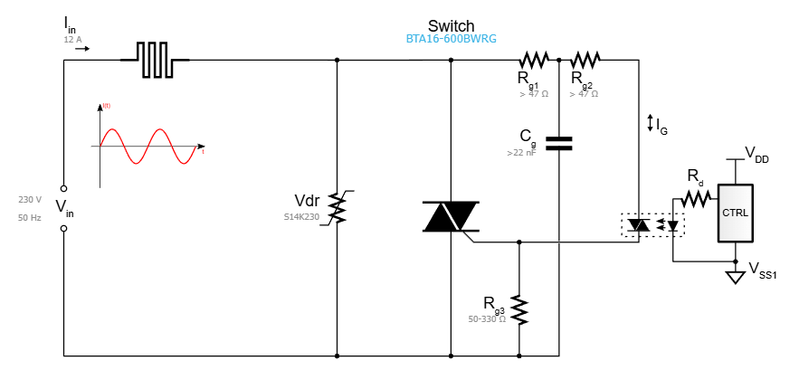
Figure 1: Heater Power Control ST Schematics

From the list of TRIACs suggested by ST, we will select the device with the lowest power dissipation. However, before making a final choice, we must refine the simulation parameters: 12 A_{RMS} is too high to handle without an adequate heatsink.
In the ST simulator, under the heatsink selection options, we choose “Case in Environment” and set the environment temperature to 50 °C (estimated internal temperature inside a closed enclosure).
With these conditions, the BTA16-600BW appears to be a good candidate:
- I_{RMS} max: 16 A
- V_{DRM}/ V_{RRM}: 600 V
From the datasheet, in Figure 2: “Maximum power dissipation versus on‑state RMS current (full cycle)”, the expected power dissipation at 12 A_{RMS} is approximately 13W.

Heatsink
To dissipate these 13 W, we need a heatsink such that the total thermal resistance keeps the TRIAC junction below its maximum temperature. The required heatsink thermal resistance Rth(sa) can be calculated with:
$$P=\frac{(Tjmax-Ta)}{Rth\left(jc\right)+Rth\left(cs\right)+Rth(sa)}$$
From the datasheet and our assumptions:
-Rth(jc) = 2.1°C/W
-Tjmax = 125°C.
-Ta = 50°C (temperature inside the box)
-Rth(cs) = 0.5°C/W
$Rth\left(sa\right)=\frac{\left(Tjmax-Ta\right)}{P}- Rth\left(jc\right)-Rth\left(cs\right)= \frac{\left(125-50\right)}{13}- 2.1-0.5=3.17°C/W$
To safely dissipate 13 W at a 50°C ambient temperature inside the enclosure, we will need a heatsink with a thermal resistance of 3.17 °C/W or lower (the lower the value, the more effective the heatsink).
We will choose Heatsink 530002B02500G from BOYD for our design
The heatsink 530002B02500G from BOYD has a thermal resistance of 2.6 °C/W. At 14 W, it will cause a temperature rise of about 50°C (see thermal graph from datasheet) above the ambient temperature inside the box. With Ta = 50 °C, the heatsink temperature will be approximately 100°C, and the TRIAC junction will remain below its maximum 125 °C limit, ensuring safe operation.

OptoTriac
The opto‑triac needs to be driven by the STM32 (max I/O output voltage 3.3 V).
It must be a zero‑crossing type and suitable for 220 V rms mains operation.
The MOC3063 is a well‑known zero‑crossing opto‑triac that meets these requirements and will be used in our design.

